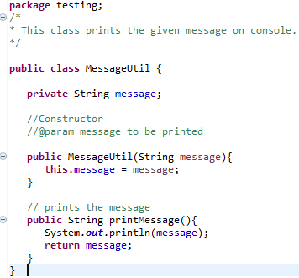

Figure : MessageUtil.java

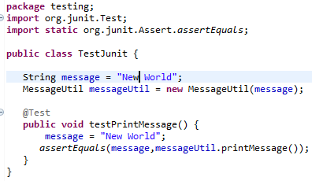

Figure : TestJunit.java

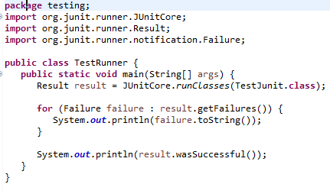

Figure : TestRunner.java

Sample java classes for Junit demo. MessageUtil.java sets the code to print a message. TestJunit.java compares a string message to a test. TestRunner.java runs the test and outputs the result.



Figure : Test Passed

The figure above shows the output when the test is passed.

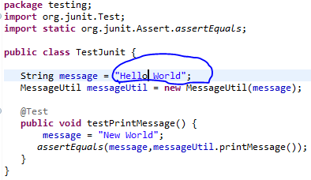

Figure : Let's make the test fail

Message changed to ‘Hello World’, rather than the correct ‘New World’.



Figure : Test Failed

The above figure shows what happens when the test fails. An extra message is printed detailing exactly what went wrong to make the test fail ie. ‘Hello’ instead of ‘New’.